Standard Operating Procedure
Steampipe-Based AWS Misconfiguration Detection & Evidence Collection
Project | CloudGuardian — CAP-CSE-3W (Cloud Security Posture Management)
Programme | IIT Roorkee × Futurense PG Certificate in AI/GenAI Powered Cybersecurity — Cohort 2025
Prepared By | Megha | Team: Vinay Kumar, Kedar Pavaskar
Tool | Steampipe (AWS Plugin) v1.x
AWS Account | 735291151388 (IAM User: Alex) | Region: ap-south-1 (Mumbai)
Scope | M01–M12 Misconfiguration Framework + CloudTrail Logging Findings
Document Type | SOP with Evidence Screenshot Placeholders

1. Purpose
This SOP defines the step-by-step procedure to detect, query, and document AWS misconfigurations using Steampipe as part of the CloudGuardian Week 2 multi-tool scanning exercise. It complements the Prowler and ScoutSuite SOPs and covers the same M01–M12 misconfiguration tracker plus CloudTrail logging findings, using SQL-based queries against the live AWS environment.

2. Scope
- AWS Account: 735291151388 (IAM User: Alex), Region: ap-south-1
- Services covered: IAM, S3, VPC/Security Groups, RDS, EC2, CloudTrail
- Misconfiguration IDs: M01–M12 (per CloudGuardian tracker) + CloudTrail logging gaps
- Execution user: kali (non-root) with valid AWS CLI credentials

3. Prerequisites
- Steampipe installed with the AWS plugin configured
- Valid AWS credentials for IAM user Alex, accessible under the kali user profile
- Steampipe service running (steampipe service start)
- Terminal access as kali user — NOT root, to avoid credential context mismatch errors

4. Procedure

4.1 Start Steampipe Service
$ whoami
kali

$ steampipe service start
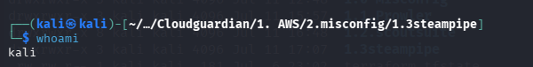🖼
Terminal — Steampipe service start confirmation

4.2 Verify AWS Connectivity
$ steampipe query "select account_id, account_aliases from aws_account"
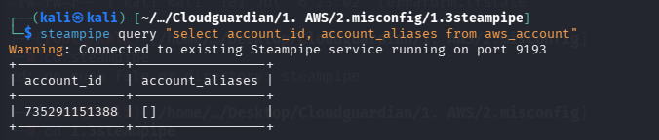
Terminal — account_id output confirming correct AWS account (735291151388)

4.3 Run Misconfiguration Queries and Export Evidence
Each misconfiguration below is queried individually and exported to a separate CSV file. Screenshots are captured for both (a) the terminal query execution with visible output, and (b) the resulting CSV opened for review.

5. Misconfiguration Queries & Evidence

M01 / M02 — IAM Wildcard Action & Resource (Inline Role Policy)
Table queried: aws_iam_role
select name as role_name,
policy -> 'PolicyName' as policy_name,
policy -> 'PolicyDocument' -> 'Statement' as statements
from aws_iam_role,
jsonb_array_elements(inline_policies_std) as policy
where name = 'cloudguardian-web-role';

Risk: EC2 role permits Action:["*"] and Resource:["*"] — full unrestricted AWS access if the instance is compromised.

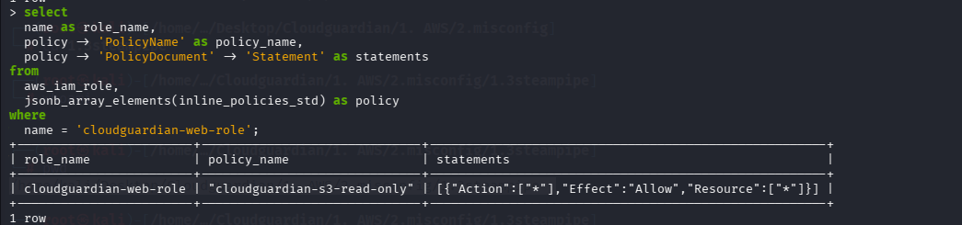
Terminal output — wildcard Action/Resource in role policy statement

M03 — AdministratorAccess Attached to EC2 Role
Table queried: aws_iam_role
select r.name as role_name, p.policy_arn
from aws_iam_role r,
jsonb_array_elements_text(r.attached_policy_arns) as p(policy_arn)
where r.name = 'cloudguardian-web-role';

Risk: AdministratorAccess managed policy grants full account admin on top of the wildcard inline policy.
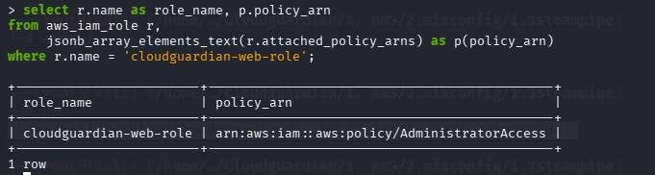
Terminal output — AdministratorAccess policy ARN attached to role

M04 — S3 Public Access Block Disabled
Table queried: aws_s3_bucket
select name, block_public_acls, block_public_policy,
ignore_public_acls, restrict_public_buckets
from aws_s3_bucket
where name like 'cloudguardian-data-%';

Risk: All four public access block flags set to false — bucket can be made public via ACL or policy.
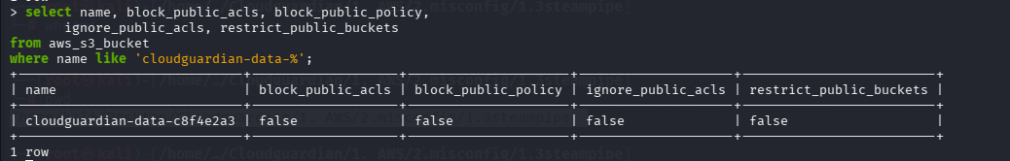
Terminal output — all block_public_* flags = false

M05 — S3 Versioning Suspended
Table queried: aws_s3_bucket
select name, versioning_enabled, versioning_mfa_delete
from aws_s3_bucket
where name like 'cloudguardian-data-%';

Risk: Versioning suspended — no recovery path for accidental or malicious object deletion/overwrite.
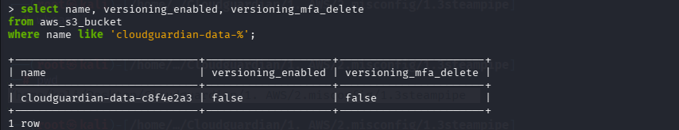
Terminal output — versioning_enabled = false

M06 — Security Group — SSH (22) Open to 0.0.0.0/0
Table queried: aws_vpc_security_group
select group_name, group_id,
ip_permission ->> 'FromPort' as from_port,
ip_permission -> 'IpRanges' as ip_ranges
from aws_vpc_security_group,
jsonb_array_elements(ip_permissions) as ip_permission
where ip_permission ->> 'FromPort' = '22'
and ip_permission -> 'IpRanges' @> '[{"CidrIp": "0.0.0.0/0"}]';

Risk: SSH exposed to the entire internet — brute-force and credential-stuffing risk.
🖼 SCREENSHOT PLACEHOLDER
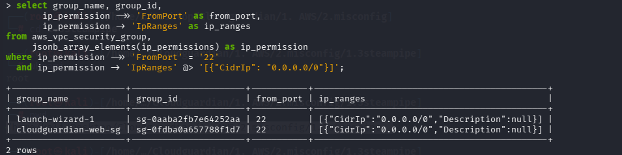
Terminal output — port 22 rule with CidrIp 0.0.0.0/0

M07 — Security Group — MySQL (3306) Open to 0.0.0.0/0
Table queried: aws_vpc_security_group
select group_name, group_id,
ip_permission ->> 'FromPort' as from_port,
ip_permission -> 'IpRanges' as ip_ranges
from aws_vpc_security_group,
jsonb_array_elements(ip_permissions) as ip_permission
where ip_permission ->> 'FromPort' = '3306'
and ip_permission -> 'IpRanges' @> '[{"CidrIp": "0.0.0.0/0"}]';

Risk: Database port directly reachable from the internet, bypassing the intended internal-only access.

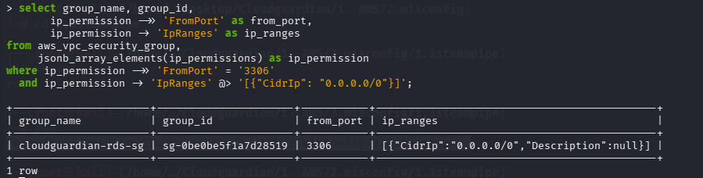
Terminal output — port 3306 rule with CidrIp 0.0.0.0/0

M08 — RDS Publicly Accessible
Table queried: aws_rds_db_instance
select db_instance_identifier, publicly_accessible, vpc_id
from aws_rds_db_instance
where db_instance_identifier = 'cloudguardian-db';

Risk: Database has a public DNS endpoint — compliance violation regardless of SG restrictions (PCI-DSS 6.4).
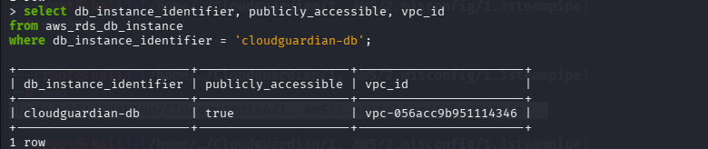
Terminal output — publicly_accessible = true

M09 — RDS Storage Encryption Disabled
Table queried: aws_rds_db_instance
select db_instance_identifier, storage_encrypted, kms_key_id
from aws_rds_db_instance
where db_instance_identifier = 'cloudguardian-db';

Risk: Data at rest stored unencrypted on EBS volumes — full exposure risk on snapshot theft or disk access.
🖼 SCREENSHOT PLACEHOLDER
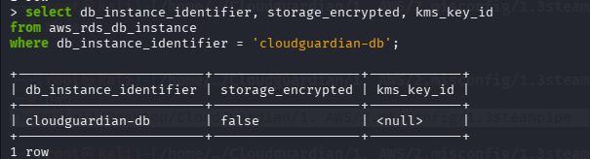
Terminal output — storage_encrypted = false

M10 — S3 Default Encryption Missing
Table queried: aws_s3_bucket
select name, server_side_encryption_configuration
from aws_s3_bucket
where name like 'cloudguardian-data-%';

Risk: No default SSE configuration — new objects stored unencrypted (GDPR/HIPAA/PCI-DSS violation).
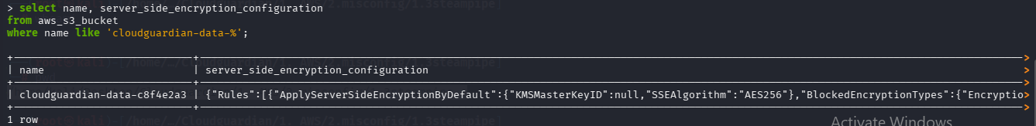
Terminal output — server_side_encryption_configuration = null

M11 — EC2 IMDSv2 Not Enforced
Table queried: aws_ec2_instance
select instance_id, tags ->> 'Name' as name,
metadata_options ->> 'HttpTokens' as http_tokens,
metadata_options ->> 'HttpPutResponseHopLimit' as hop_limit
from aws_ec2_instance
where tags ->> 'Name' = 'cloudguardian-web';

Risk: http_tokens = optional allows legacy IMDSv1 — SSRF credential-theft path (same class as the 2019 Capital One breach).
🖼 SCREENSHOT PLACEHOLDER
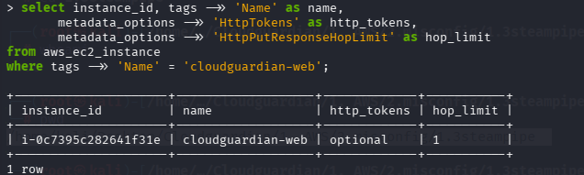
Terminal output — HttpTokens = optional

M12 — RDS Automated Backups Disabled
Table queried: aws_rds_db_instance
select db_instance_identifier, backup_retention_period,
preferred_backup_window
from aws_rds_db_instance
where db_instance_identifier = 'cloudguardian-db';

Risk: backup_retention_period = 0 disables automated backups and Point-in-Time Recovery — zero RPO.
🖼 SCREENSHOT PLACEHOLDER
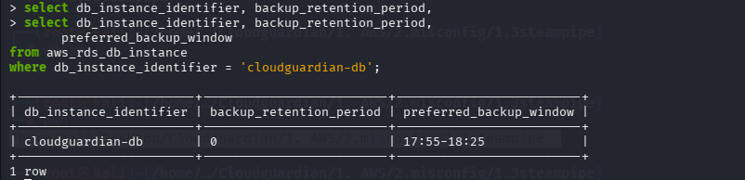
Terminal output — backup_retention_period = 0

CloudTrail — Logging, Validation & Multi-Region Coverage Gaps
Table queried: aws_cloudtrail_trail
select name, is_logging, log_file_validation_enabled,
is_multi_region_trail, include_global_service_events,
kms_key_id, log_group_arn
from aws_cloudtrail_trail
where name = 'cloudguardian-trail';

Risk: Log file validation off (tamper risk), single-region trail (coverage gap), global service events excluded (IAM/STS activity unlogged).
🖼 SCREENSHOT PLACEHOLDER
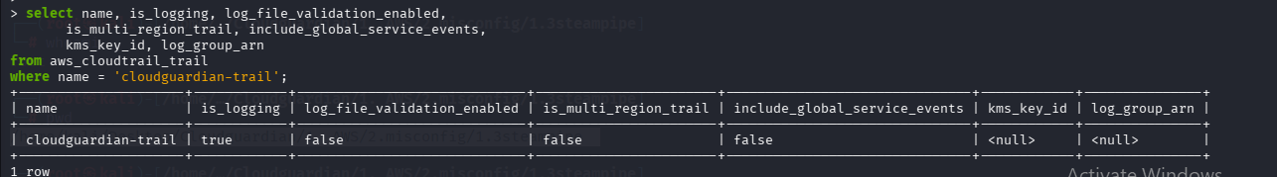
Terminal output — validation/multi-region/global-events flags

6. Findings Summary Table
To be completed after evidence collection — mirrors the M01–M12 tracker for cross-tool comparison.
Misconfig ID | Finding | Service | Steampipe Status | Severity
M01/M02 | Wildcard Action + Resource in inline IAM policy | IAM
M03 | AdministratorAccess attached to EC2 role | IAM
M04 | S3 public access block disabled | S3
M05 | S3 versioning suspended | S3
M06 | SSH (22) open to 0.0.0.0/0 | VPC/SG
M07 | MySQL (3306) open to 0.0.0.0/0 | VPC/SG
M08 | RDS publicly accessible | RDS
M09 | RDS storage encryption disabled | RDS
M10 | S3 default encryption missing | S3
M11 | EC2 IMDSv2 not enforced | EC2
M12 | RDS automated backups disabled | RDS
— | CloudTrail logging/validation/region gaps | CloudTrail

7. Sign-Off
- Prepared by: Megha
- Reviewed by: _______________________
- Date: _______________________

